|  |
| --- |
| Software Design Specification  Elite Event Planner  Project Code  Internal Advisor  Miss Samreen Razzaq  External Advisor  Project Manager  Dr. Hussam Ali  Project Team  Hamza Abbas (MSIT62F21S038) Team Leader  Faisal Mustafa (MSIT62F21S028) Team Member  Haseeb Alam (MSIT62F21S050) Team Member  Submission Date:  24-May-2023 _____________________   Project Manager’s Signature |

**Document Information**

| Category | Information |
| --- | --- |
| Customer | UOS |
| Project | Elite Event Planner |
| Document | Software Design Specification |
| Document Version | 1.0 |
| Identifier | <PGBH01-2003-DS> |
| Status | Draft |
| Author(s) | Haseeb Alam,Faisal Mustafa,Hamza Abbas |
| Approver(s) | PM |
| Issue Date | Sept. 15, 2003 |
| Document Location |  |
| Distribution | 1. Advisor 2. PM 3. Project Office |

**Definition of Terms, Acronyms and Abbreviations**

This section should provide the definitions of all terms, acronyms, and abbreviations required to interpret the terms used in the document properly.

| Term | Description |
| --- | --- |
| ASP | Active Server Pages |
| DD | Design Specification |
| RS | Requirements Specifications |
| PHP | Hypertext Preprocessor |
| SQL | Structured query language |
| CSS | Cascading Style Sheets |
| HTML | Hyper Text Markup Language |
|  |  |

**Table of Contents**

1. Introduction 4

1.1 Purpose of Document 4

1.2 Project Overview 4

1.3 Scope 4

2. Design Considerations 4

2.1 Assumptions and Dependencies 4

2.2 Risks and Volatile Areas 4

3. System Architecture 4

3.1 System Level Architecture 4

3.2 Sub-System / Component / Module Level Architecture 5

3.3 Sub-Component / Sub-Module Level Architecture (1…n) 5

4. Design Strategies 5

4.1 Strategy 1…n 5

5. Detailed System Design 5

6. References 6

7. Appendices 6

# Introduction

* 1. Purpose of Document

The purpose of this document is to give a detailed description of the deserving people’s requirements of the "Elite Event Planner" Website. It will also explain software constraints, hardware constraints, Environment constraints and interface and user characteristic functional requirements and non-functional requirements for the project.

* 1. Project Overview

Now a days, everyone is so much busy in daily life’s routine. They have not much time for organizing their special events. So we are providing a platform where they could hire’s an event planner for organizing their events. An event planner is a professional who is specialize in this field and responsible for organizing and coordinating various types of events, such as weddings, corporate meetings, conferences, festivals, parties, ceremonies and other special occasions. Their main objective is to ensure that the event runs smoothly on time, and within budget, while also meeting the specific needs and expectations of the clients and attendees.

Event planners face a challenge in showcasing their skills, expertise, and past work in a centralized and effective manner. There is a need for a dedicated online platform that allows event planners to create detailed profiles featuring their portfolio, successful events, and client testimonials. Our website seeks to bridge this gap by providing event planners with a comprehensive platform to highlight their unique strengths and attract potential clients.

* 1. Scope

Our system can handle Wedding events, Cooperative events, Social events, catering services and decorating Services and accessories of both bridal and groom and providing many other services. Our system only organizing Pakistan Muslims events and not other minorities. And also we are not organizing political events.

In the previous days, there is no need of event planner because peoples are not organizing many events as compared to now a day. Now a days event planner became a formalized profession and the scope of events expanded. “Elite Project Planner” project could be used publicly. Any person which wants to organize any type of event, he can hire event planner anytime.

The scope of the event planners is quite broad, as events are a common occurrence in many industries and communities. Event planners can work with a variety of clients, including individuals, corporate clients, social clients, non-profit organizations, government agencies and educational institutions. The target market for event planners can vary depending on the type of event being planned, but generally includes individuals or organizations that require assistance in organizing and executing a successful event. This can include:

1. **Corporate clients:** These are businesses and organizations that need event planning services for conferences, product launches, trade shows, team building events, and other corporate events.
2. **Non-profit organizations:** These are charities, foundations, and other non-profit organizations that require event planning services for fundraisers, galas, charity auctions, and other events to raise awareness and funds.
3. **Social clients:** These are individuals who require event planning services for personal events such as weddings, birthdays, anniversary parties, baby showers, and other special occasions.
4. **Government agencies:** These are public sector organizations that require event planning services for public events, such as inaugurations, official openings, and other public events.
5. **Educational institutions:** These are schools, universities, and other educational institutions that require event planning services for graduation ceremonies, conferences, workshops, and other events.

# 2. Design Considerations

Design Considerations for an Event Planner Website:

**User Experience (UX):**

* **Intuitive Navigation:** The website has a user-friendly interface with clear navigation menus and well-structured content, allowing users to easily find information and services.
* **Responsive Design:** This website is mobile-friendly that adapts seamlessly to different devices and screen sizes, providing a consistent experience across platforms.
* **User-Focused Approach:** This website will understand the target audience and design cater to their needs and preferences, keeping their demographics, behaviors, and goals in mind.
* **Accessibility:** This website will accessible to users with disabilities by following accessibility standards and guidelines, such as providing alt text for images and using proper color contrast.

**Event Information and Services:**

* **Clear Event Descriptions:** Display detailed information about each event, including date, time, location, agenda, speakers, and any additional relevant details.
* **Service Offerings:** Highlight the range of event planning services offered, such as venue selection, event marketing, catering, audiovisual setup, and logistics management.
* **Online Booking and Registration:** Provide a seamless process for users to book tickets, register for events, and make payments securely.

**Event Portfolio and Testimonials:**

* **Showcase Past Events:** Feature a visually appealing portfolio of past events to demonstrate the expertise and creativity of the event planning team.
* **Client Testimonials:** Include testimonials from satisfied clients to build trust and credibility, highlighting successful events and positive experiences.

**Reviews and Ratings:**

* Implement a system for users to rate and review vendors, helping others make informed decisions and maintaining a quality network of partners.

**. Contact and Support:**

* **Contact Information:** Clearly display contact details, including phone number, email address, and physical address, enabling users to reach out for inquiries or support.
* **Live Chat or Chatbot:** Integrate a live chat feature or chatbot to provide instant assistance and answer frequently asked questions.

**. Security and Privacy:**

* **Secure Transactions:** Implement SSL certificates and secure payment gateways to ensure that financial transactions are protected.
* **Privacy Policy:** Include a comprehensive privacy policy that outlines how user data is collected, used, and protected, complying with relevant data protection regulations.

**. Analytics and Performance:**

* **Website Analytics:** Integrate analytics tools, such as Google Analytics, to track user behavior, measure website performance, and gain insights for improvements.
* **Page Load Speed:** Optimize the website's performance to ensure fast loading times, minimizing bounce rates and improving user experience.

By addressing these design considerations, an event planner website can provide an engaging and user-friendly experience, attract potential clients, and streamline the event planning process.

* 1. Assumptions and Dependencies

**Assumptions**:

1. There is a market demand for event planning services, and people are willing to pay for such services.
2. The event planning industry is competitive, with many players offering similar services.
3. The company has access to a pool of talented and experienced event planners who are willing to work on a freelance or contract basis.
4. The company has access to the necessary technology and software to manage and coordinate events effectively.
5. The company has a good reputation in the market, and clients trust them to deliver high-quality event planning services.

**Dependencies**:

1. Availability of skilled and experienced event planners who are willing to work on a freelance or contract basis.
2. Availability of reliable vendors who can provide services such as catering, audio-visual equipment, and transportation etc.
3. Availability of suitable venues that can accommodate the client's requirements.
4. Availability of necessary permits and licenses to hold events in specific locations.
5. Access to sufficient funding to cover expenses such as salaries, equipment, and marketing costs.
6. Dependency on a banking system for online payment tranaction.
   1. Risks and Volatile Areas

Risks and Volatile Areas of Event Planner Website are:

1. **Technical Risks:**

* **System Failure:** The website may experience technical issues such as server downtime, data corruption, or network outages, leading to a loss of functionality and user frustration.
* **Security Vulnerabilities:** Hackers may exploit vulnerabilities in the website's code, leading to unauthorized access, data breaches, or service disruption.
* **Compatibility Issues:** The website may not function properly across different browsers, devices, or operating systems, resulting in a poor user experience.

1. **Data Management Risks:**

* **Data Loss:** There is a risk of data loss due to hardware failure, software bugs, or human error. This could lead to the loss of critical information related to events, bookings, or customer details.
* **Privacy Concerns:** The website needs to handle personal and sensitive data, such as payment information or contact details. Inadequate security measures or mishandling of data could result in privacy breaches and damage to the reputation of the event planner.

1. **Changing Requirements and Technology:**

* **Evolving Customer Expectations:** Customer demands and expectations for event planning services may change over time. The website should be adaptable to meet new requirements and provide enhanced features to cater to evolving needs.
* **Emerging Technologies:** Advancements in technology, such as new web development frameworks, payment gateways, or event management tools, may require system updates or integration to stay competitive and deliver a seamless user experience.

1. **Contingency Plan for Changes and Timely Response:**

* **Agile Development Approach:** The system should be designed using an Agile methodology, allowing for incremental and iterative development. This enables the team to respond quickly to changes, adapt the system's design, and incorporate new requirements in a timely manner.
* **Modular and Scalable Architecture:** The system should be built with a modular and scalable architecture, allowing for easy modification and addition of new features. This flexibility will ensure that the website can adapt to changing requirements and accommodate future enhancements without requiring a complete redesign.
* **Continuous Integration and Deployment:** Implementing continuous integration and deployment practices will enable rapid and frequent updates to the system. Automated testing and deployment pipelines will help identify issues early and ensure a smooth transition of new features or changes into production.
* **Regular Risk Assessment and Security Audits:** The event planner website should undergo regular risk assessments and security audits to identify vulnerabilities and address them promptly. This proactive approach will mitigate security risks and protect the website and user data from potential threats.
* **User Feedback and Iterative Improvements:** By actively seeking user feedback and conducting usability testing, the system can gather valuable insights for improvements. Regularly analyzing user feedback will help identify areas that require modification or new features, enabling the website to stay aligned with changing user needs and preferences.

# By considering these risks, incorporating an agile development approach, and implementing the contingency plan, the event planner website can effectively handle changes, adapt to evolving requirements, and ensure a seamless user experience.

# System Architecture

This section should provide a high-level overview of how the functionality and responsibilities of the system are partitioned and then assigned to subsystems or components. The main purpose is to gain a general understanding of how the system is decomposed, and how the individual parts work together to provide the desired functionality.

* 1. System Level Architecture

In this project, we used two Tier Architecture Diagram. It is a client server architecture in which the functional process logic, data access, computer data storage and user interface are developed and maintained on same platform. A two-tier architecture which we are using in our Application is a software architecture in which a presentation layer or interface runs on a client, and a data layer or data structure gets stored on a server. Separating these two components into different locations represents a two-tier architecture, as opposed to a single-tier architecture.

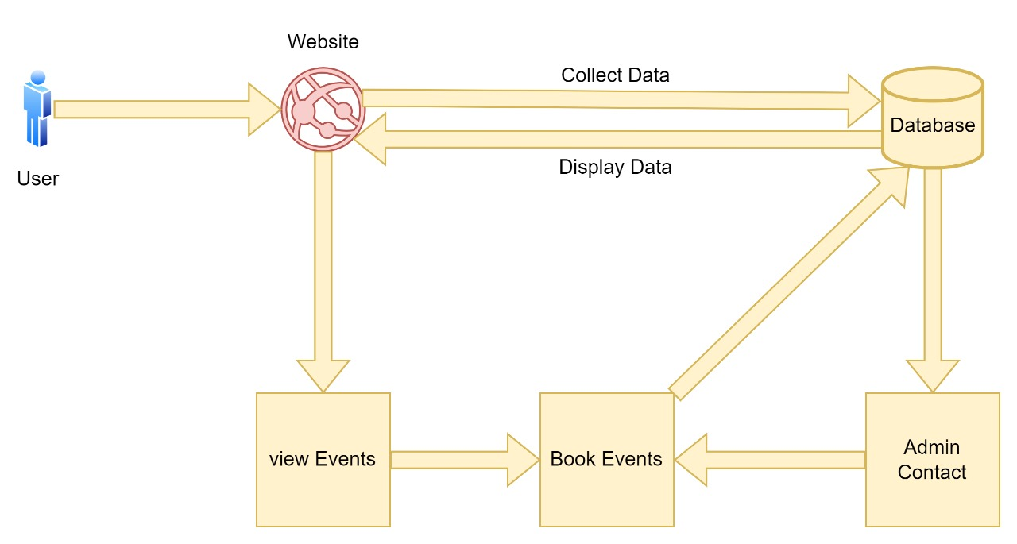

Figure 1: System Architecture Diagram

0 level DFD:

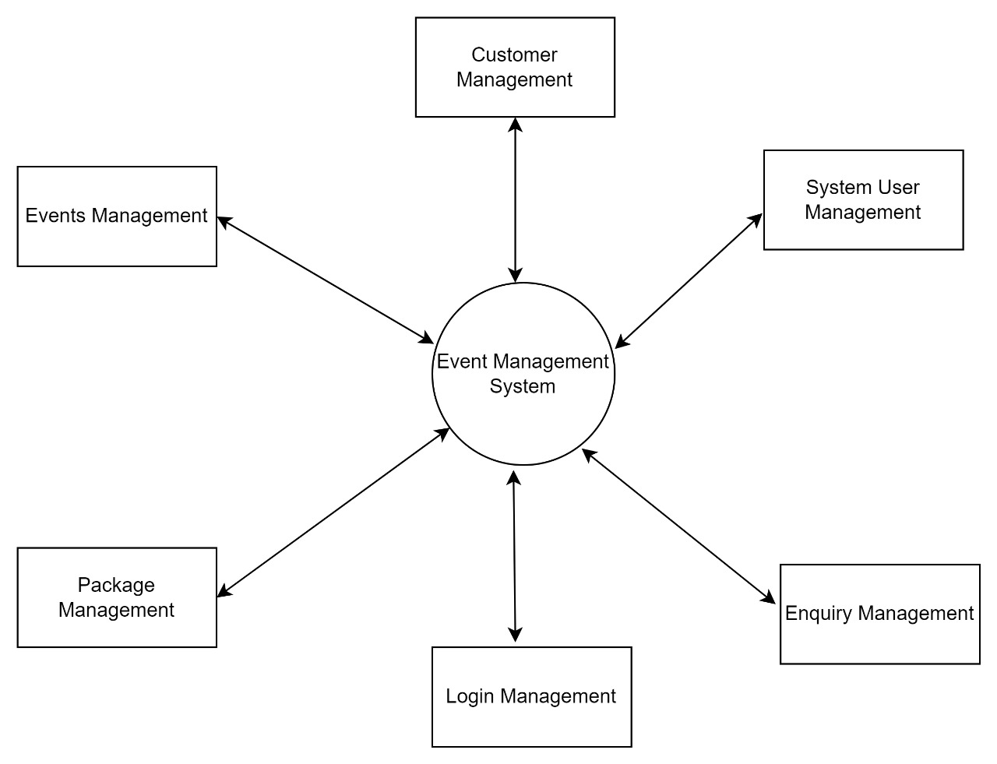

Figure 2: Zero Level DFD

Description:

This is Zero level DFD of Events Managements system where we have explained the high level process .It is basic overview of whole Events management system or process being analyze or model.

1 level DFD:

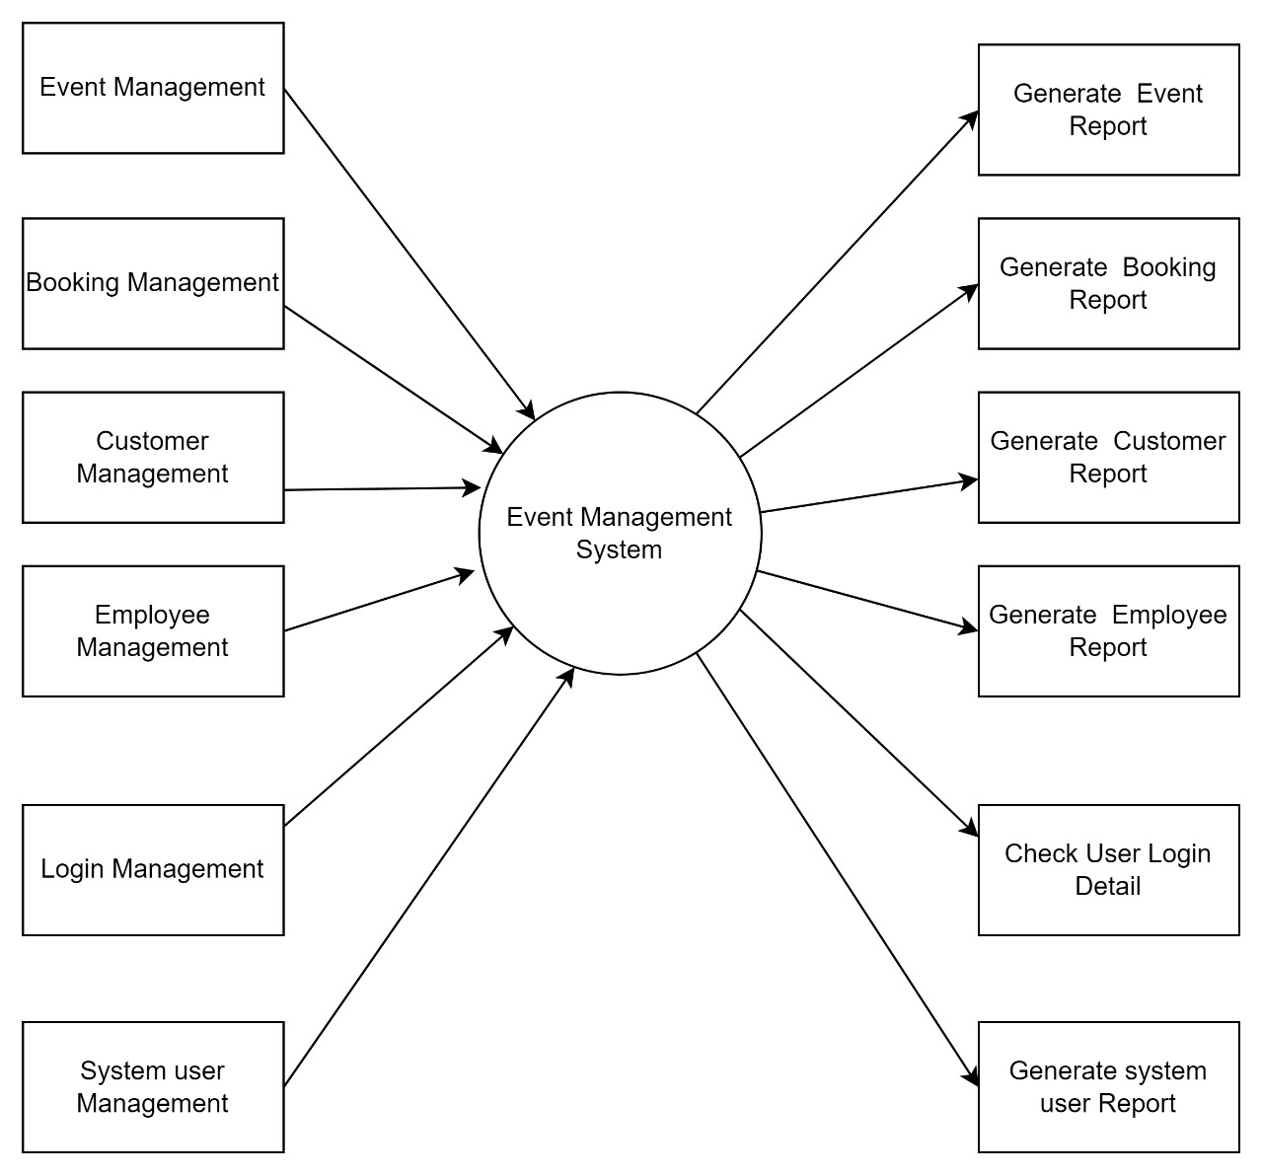

Figure 3: Level 1 DFD

Description:

This is the first level DFD of Events management System, each of which deals with one or more of the data flows to or from an external agent, and which together provide all of the functionality of Events Management System as a whole. It also identifies internal data stores of Events detail.

**Main entities and output of First level DFD:**

Processing Events records and generating reports of all Events.

Processing customer records and generating reports of all customers.

Processing staff records and generating reports of all staff.

Processing reports and generating reports.

2 level DFD:

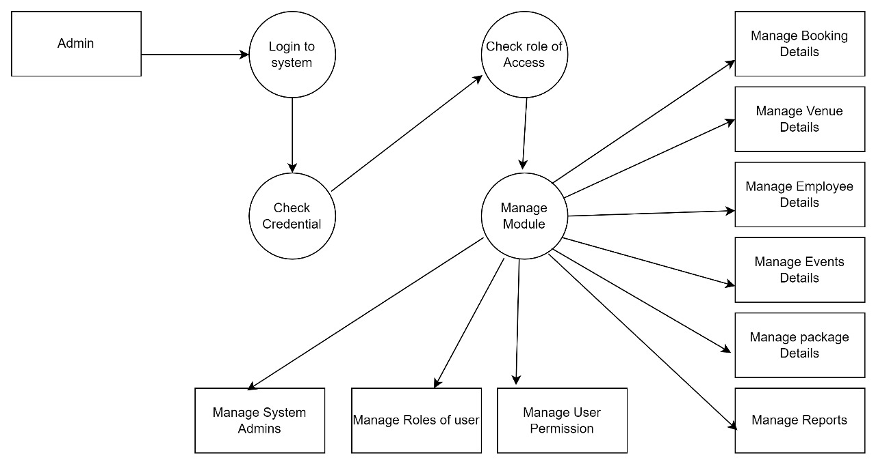

Figure 4: Two level DFD

**Description:**

This is the Second level DFD of Event management System; It may require more functionalities of record to reach the necessary level of detail about the Events. The first level DFD of Event Management System shows how the system divided into subsystems. The second level DFD contains more details of Events record, Package detail, and booking details.

**Use Case Diagrams**

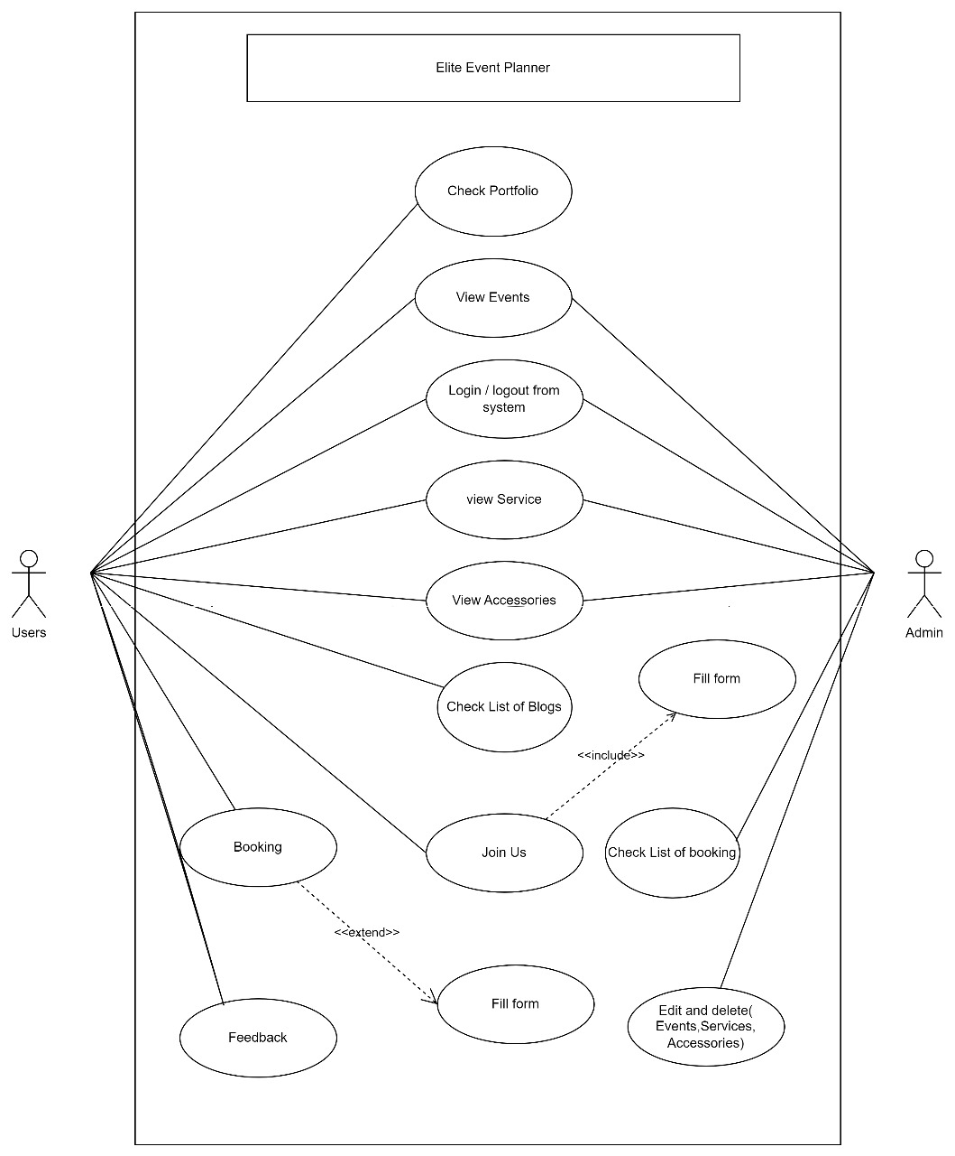

Figure 5: Use Case Diagram

# Design Strategies

Describe the design strategies or decisions that impact the overall organization of the system and its high-level structures. This information should provide the reader with insights into the key abstractions and mechanisms used in the system architecture.

* 1. Strategy 1…n

For each strategy, discuss the reasoning employed (possibly referring to previously stated design goals and principles) and any trade-offs. Areas for consideration include:

* Future system extension or enhancement
* System reuse
* User interface paradigms
* Data management (storage, distribution, persistence)
* Concurrency and synchronization

# Detailed System Design

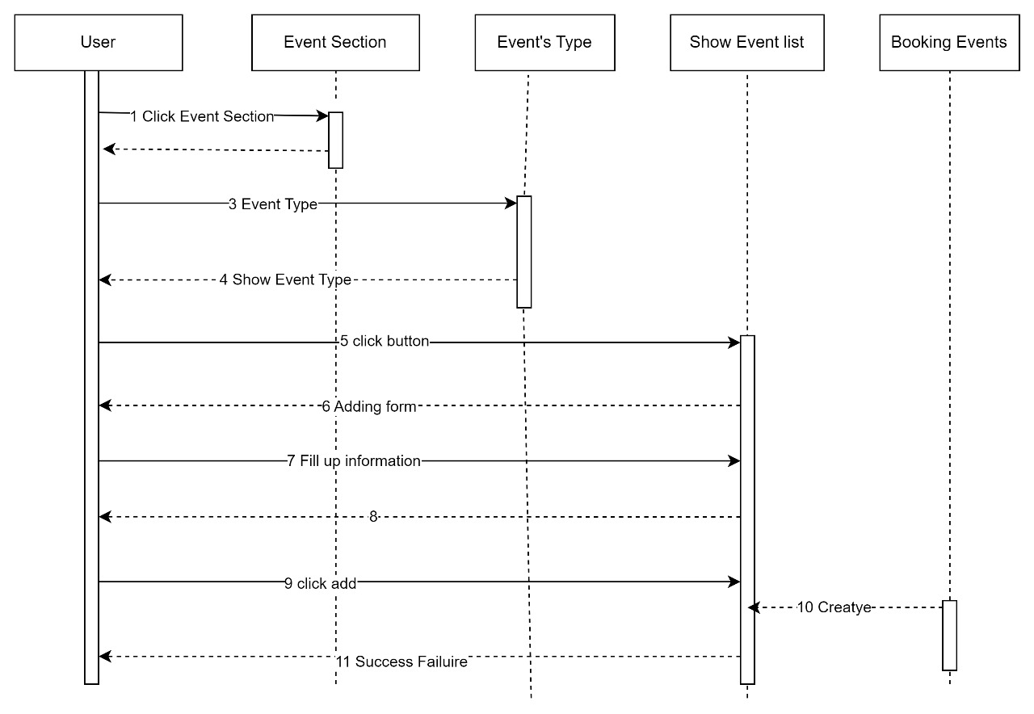

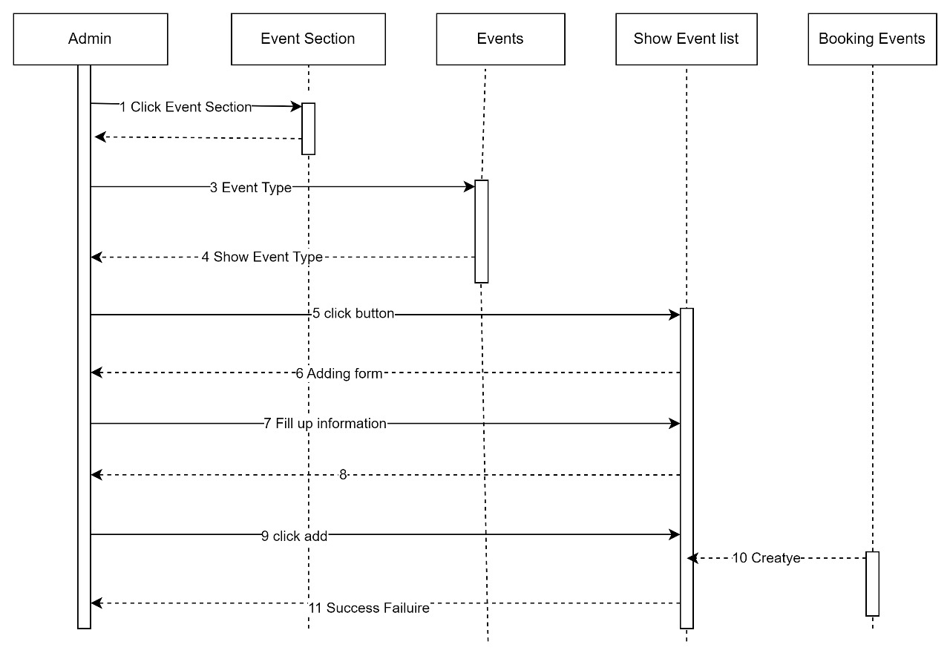

Figure 6: Sequence diagram

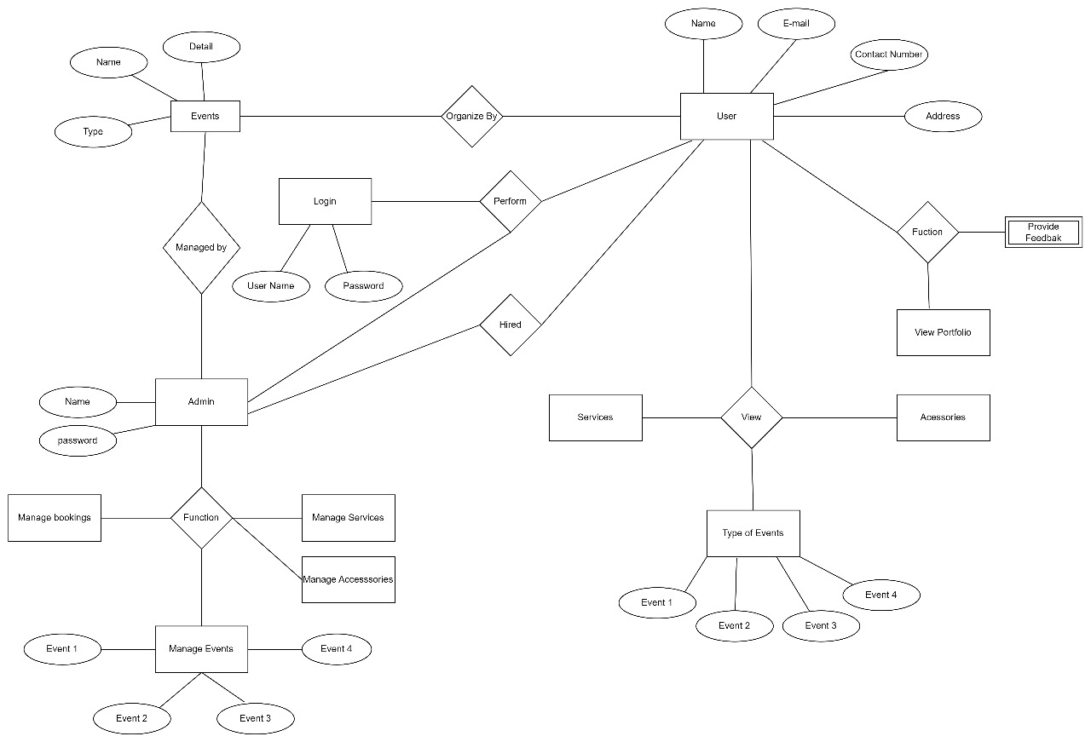

Figure 7: ER Diagram

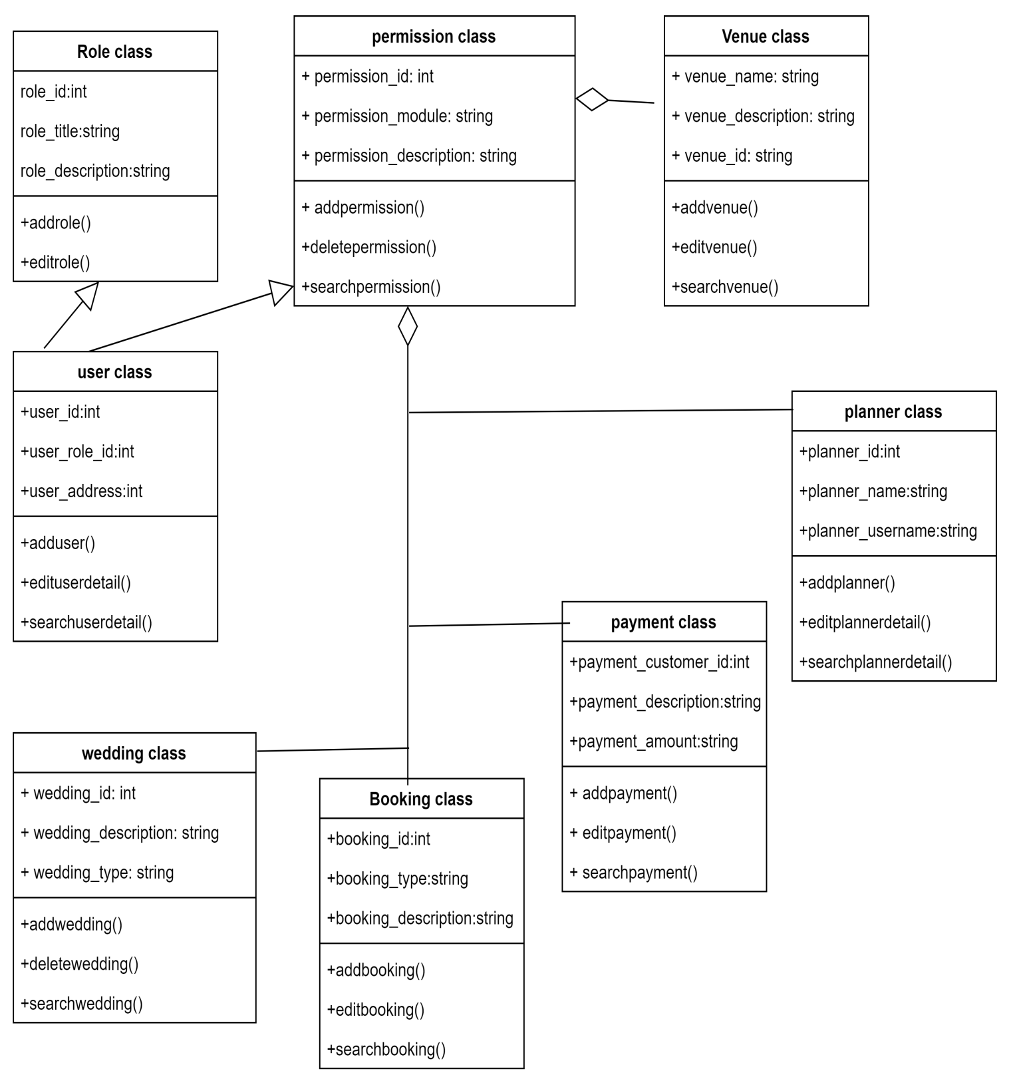

Figure 8: Class Diagram

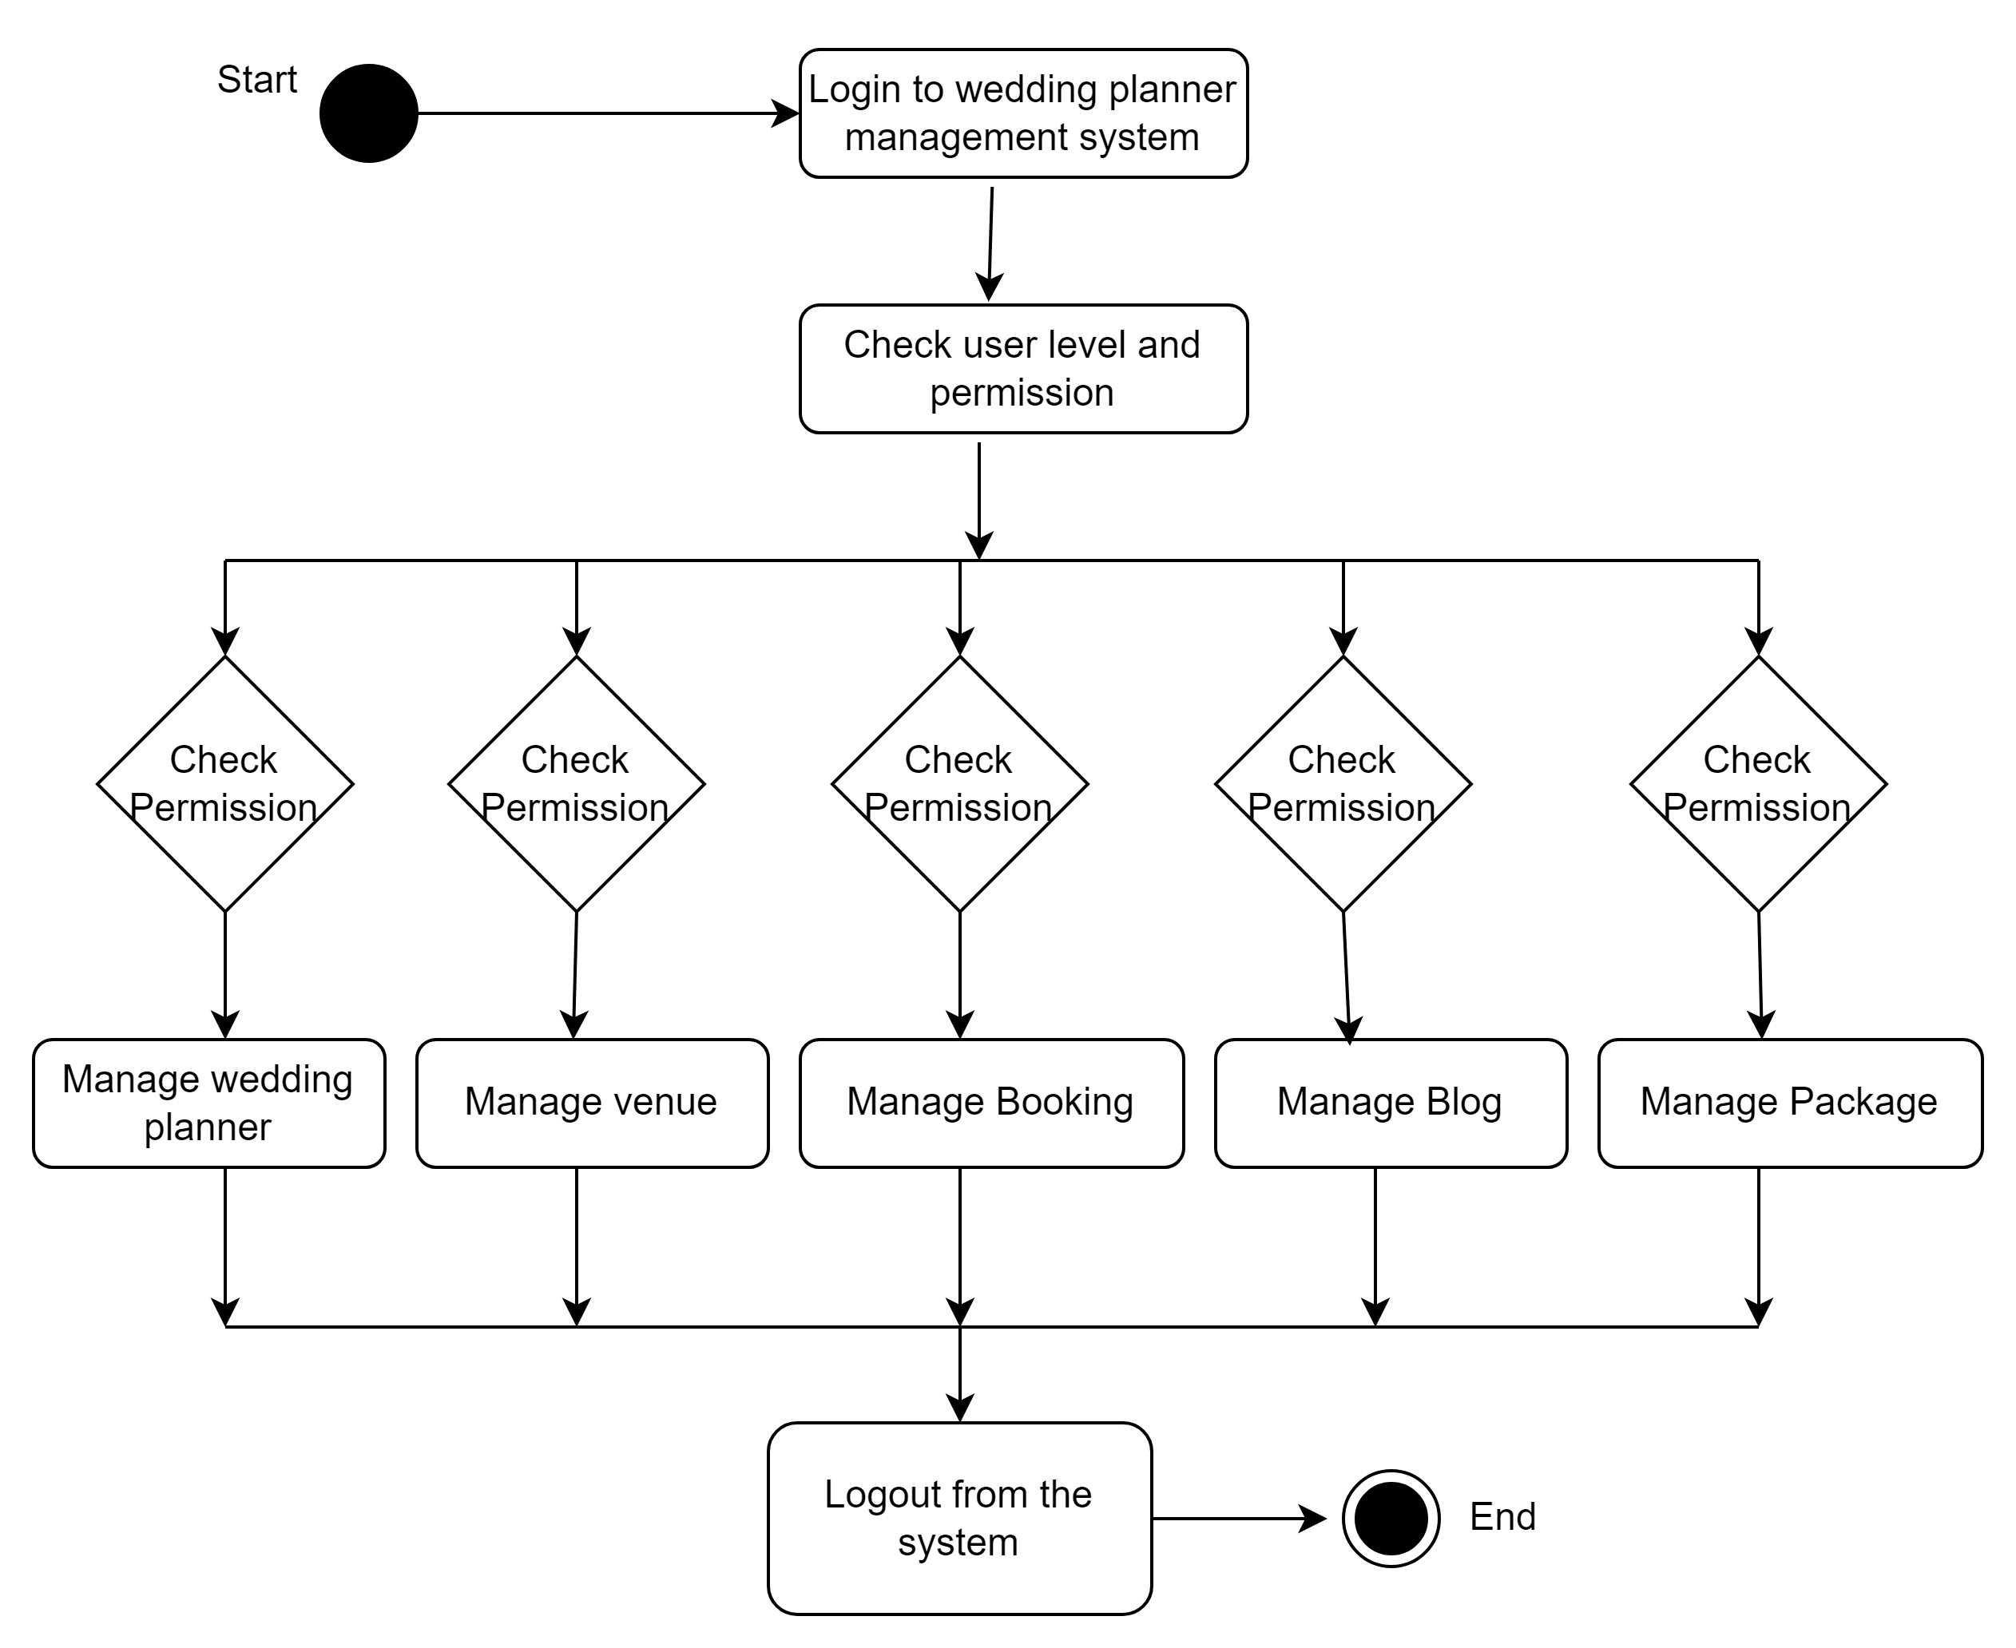

Figure 9: State Transition Diagram

**Detailed GUI:**

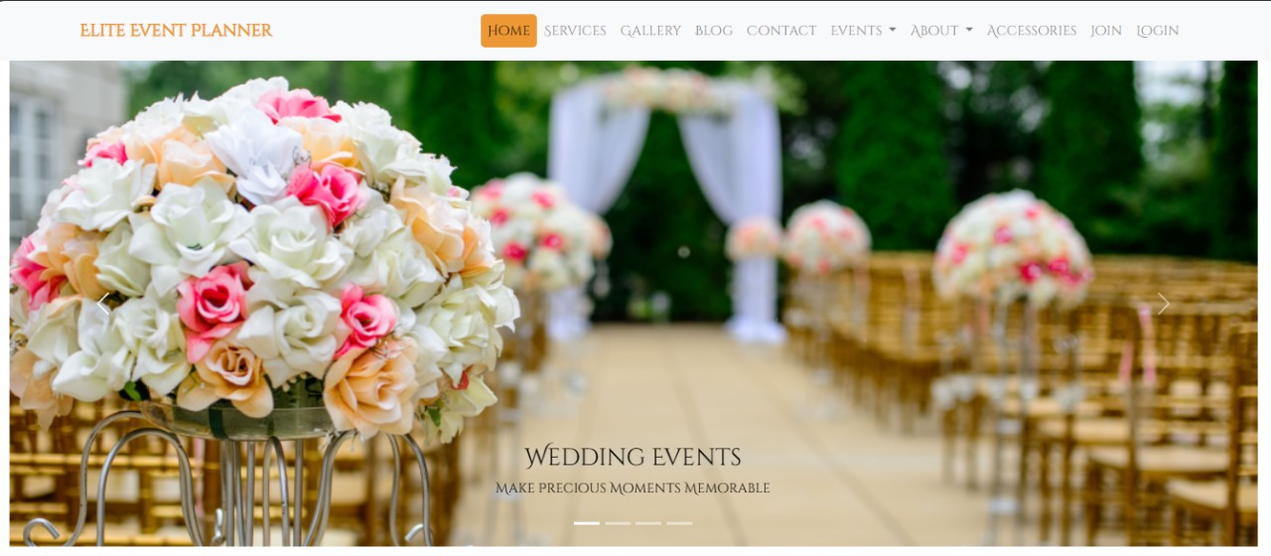

Figure 10: Home

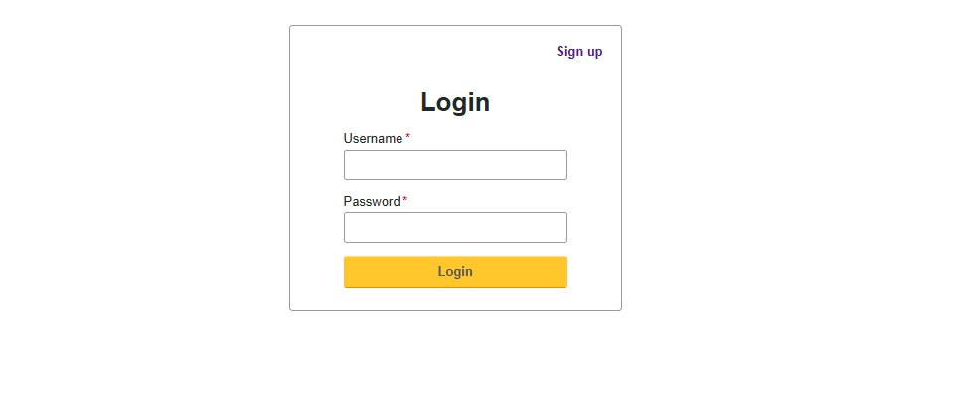

Figure 11: Login

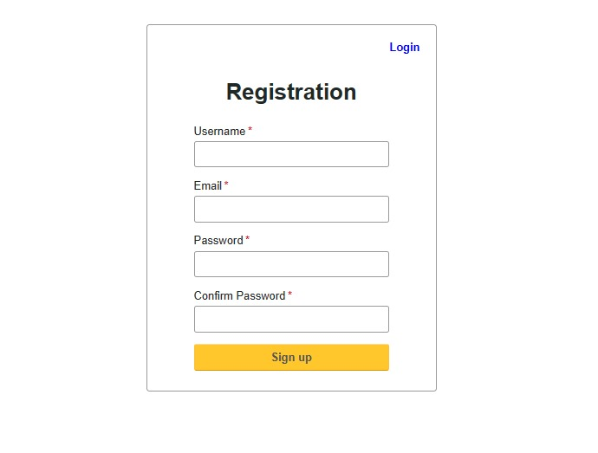Figure 12: Registration

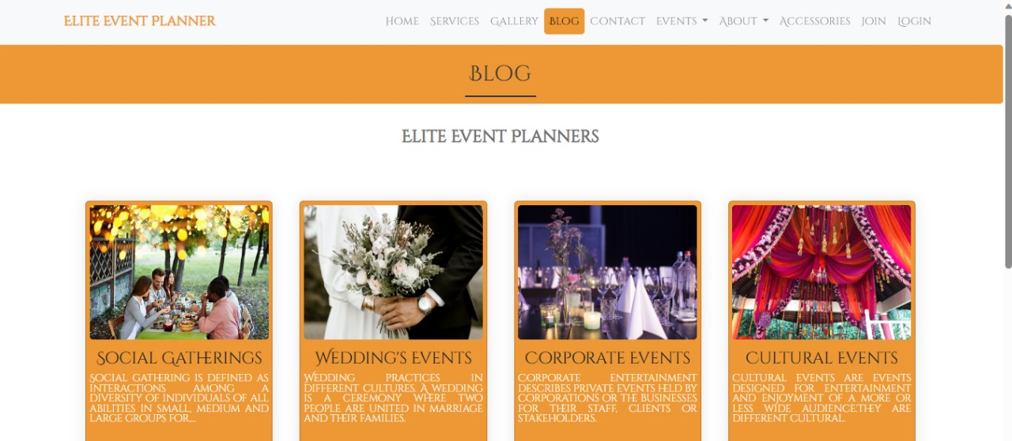

Figure 13: Blogs

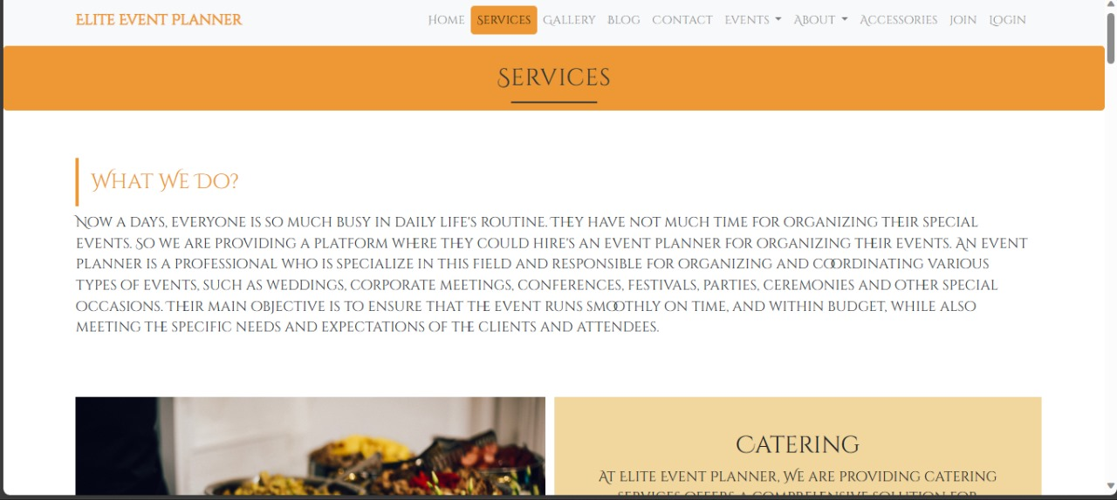

Figure 14: Services

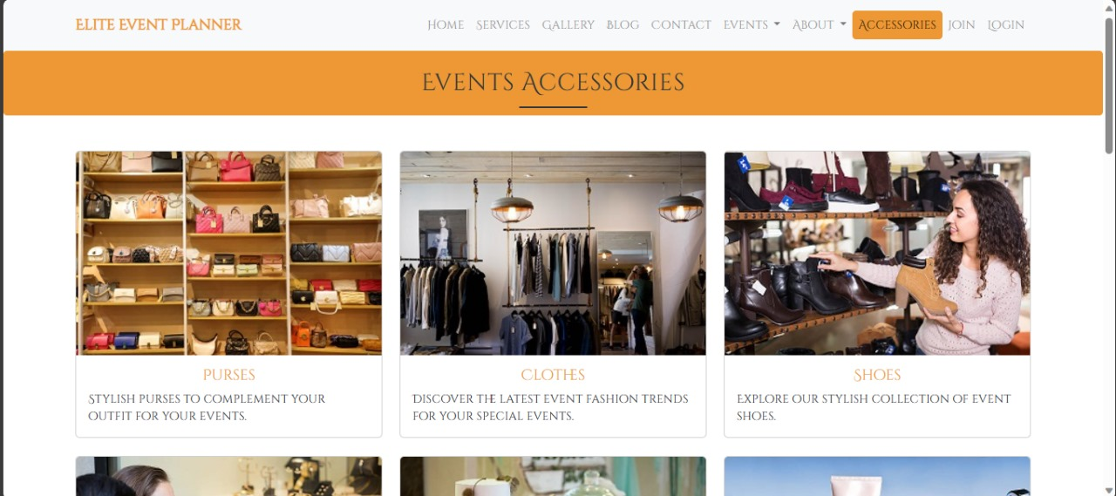

Figure 15: Accessories

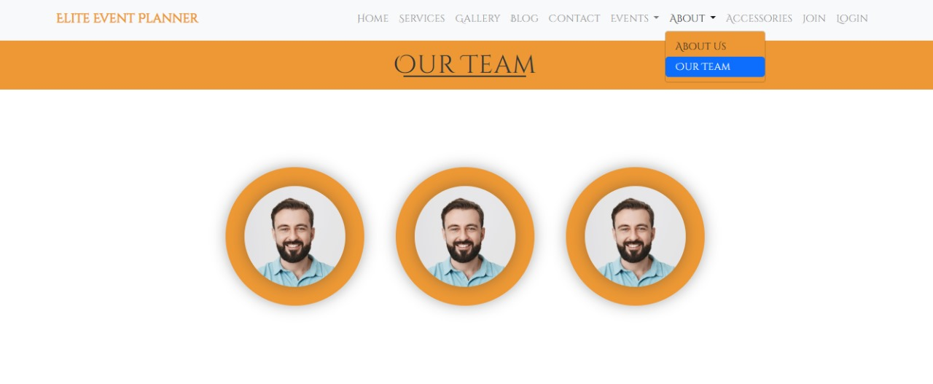

Figure 16: Our Team portfolio

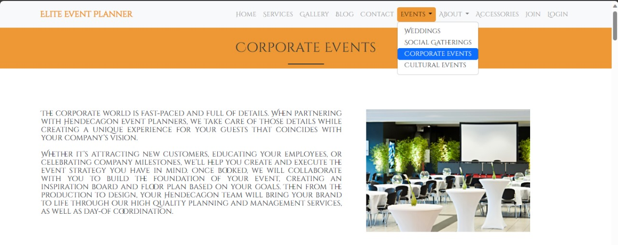

Figure 17: Events

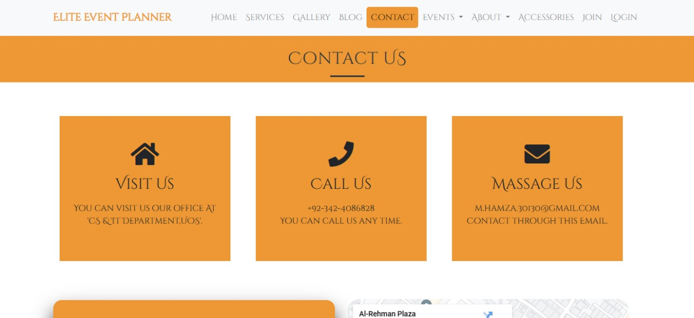

Figure 18: Contact us

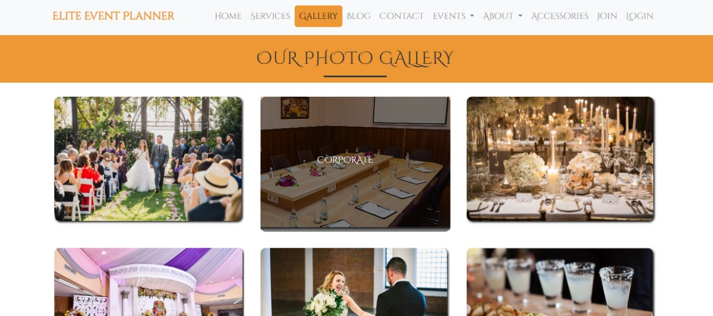

Figure 19: Gallery

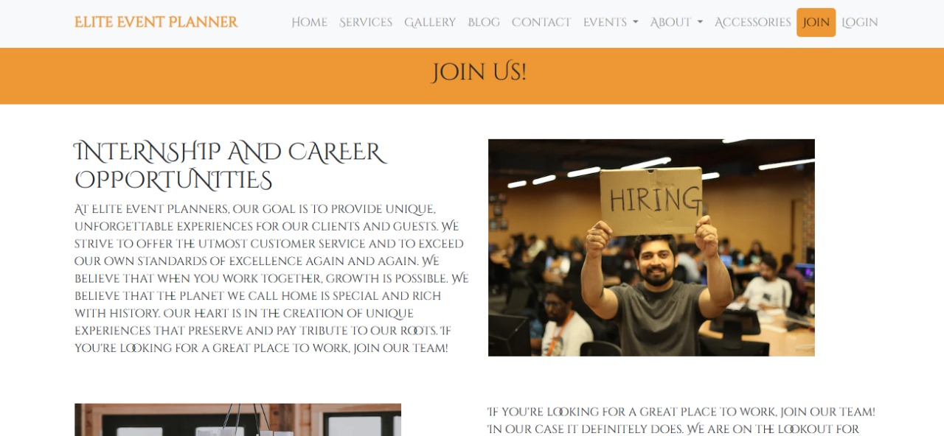

Figure 20: Join Us

# References

This section should provide a complete list of all documents referenced at specific point in time. Each document should be identified by title, report number (if applicable), date, and publishing organization. Specify the sources from which the references can be obtained (This section is like the bibliography in a published book).

|  |  |
| --- | --- |
| [1] | M. Manager, E. Smith and K. Jones, Wedding Planner Group, istanbul,dubai,london,delhi, 2022. |
| [2] | A. Almass and A. sattr, Shadi Welcome, Lahore, 2017. |
| [3] | M. Ali and M. Aslam, Eventoxs Event Management, Islambad, 2021. |
| [4] | M. Waqar, M. Areeb and A. Amna, FIND AN EVENT MANAGEMENT COMPANY, Islamabad,Lahore, 2020. |
| [5] | K. Shahzad, R. Faisal and H. Mazhar, Innovative Events Expert, Islamabad,Lahore,Multan,Gujranwala, 2019. |